

Talk to Tucker

**About The Project**

* Talk to Tucker is an Application that allows users to search the properties in Indiana with many criteria.
* Talk to Tucker allows user to calculate the Mortgage values.
* The Properties can be searched by Map, by School District, by community or by neighbourhood.
* Talk to Tucker also allows user to search properties by drawing the polygon on the map.

**Features**

* Users can register and access the account from web as well from the App.
* Convenient to search with the so many dynamic filters.
* Option to search properties “Near me”.
* Searches can be saved by the user to get the future updates.
* Like and Share the Properties.
* Property listings include large photos, virtual tours, Google maps & Street View, local school info, and more.
* User can sort the result with many options like sort by Price, Square feet, Days on Market or Lot size.
* Virtual tours of the Properties are also available.
* It's very easy to find agents and contact them from the App itself.
* User can get the detailed information year by year of the Mortgage in the app itself.
* User can save the notes and the photos for any particular Property for future reference.
* User can get the direction from the current location to the particular property.

**Technology**

* Ionic

**Domain**

Real Estate

**Major Challenges**

* UX & UI Design
* Map Plotting with so many Pins for properties.
* Filter the Properties as there are so many different filters available.

**Screen Shots**

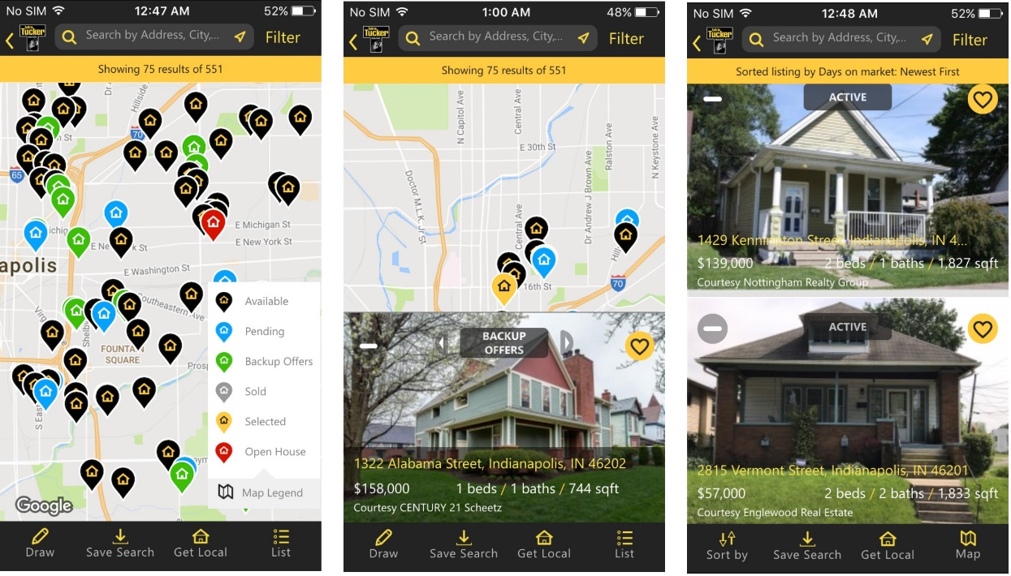

**Property Filters**

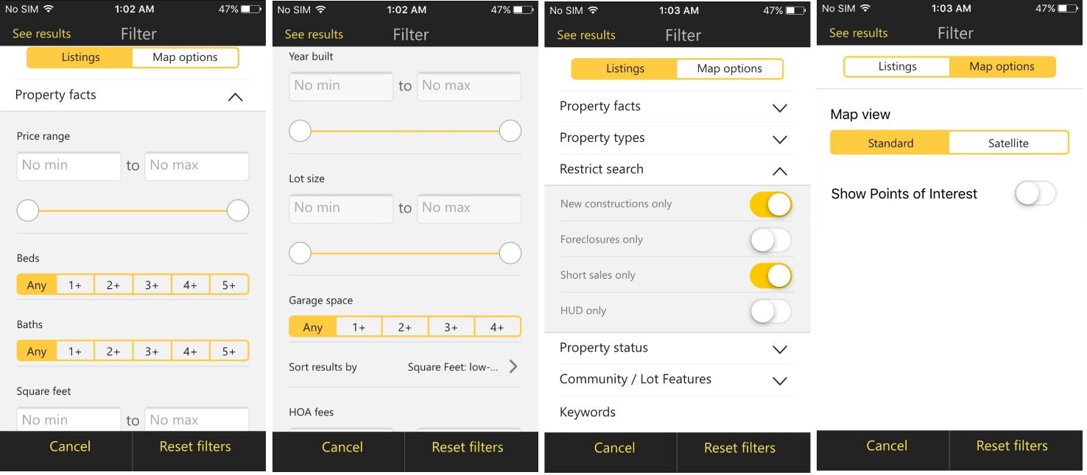

**Property Details**

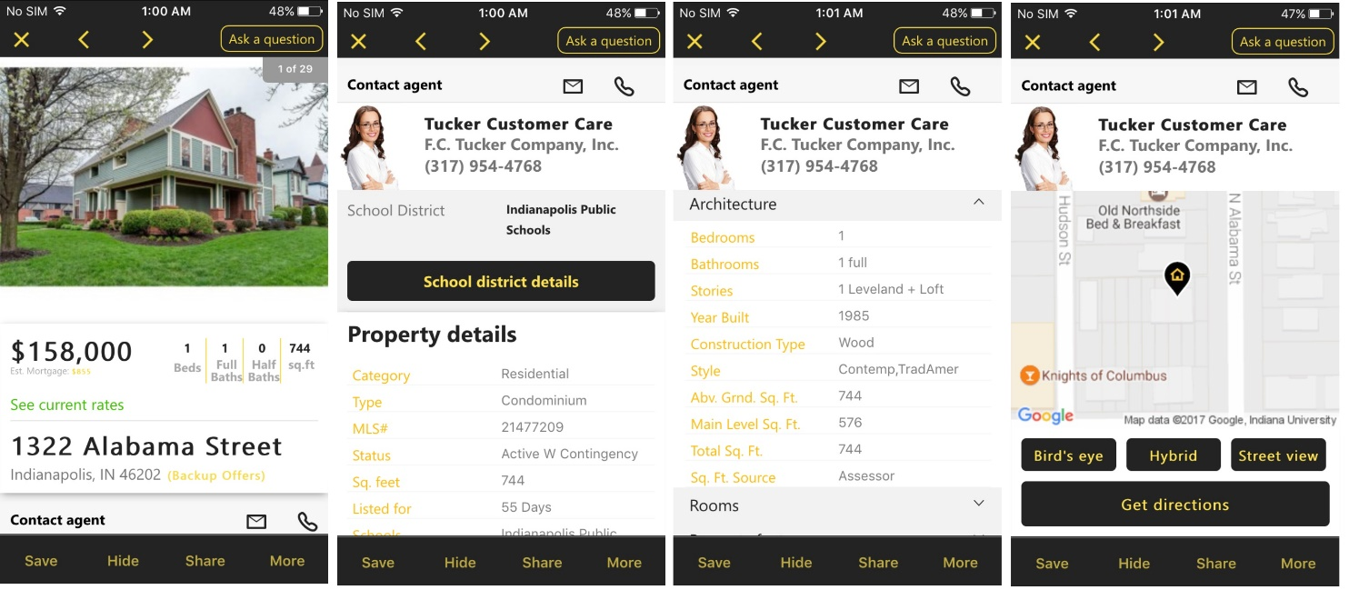

**Mortgage Calculator**

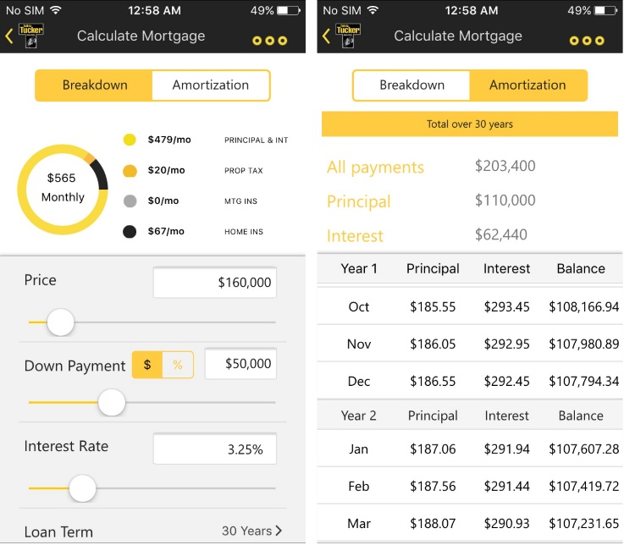

**Search by School district, Community and neighborhood**

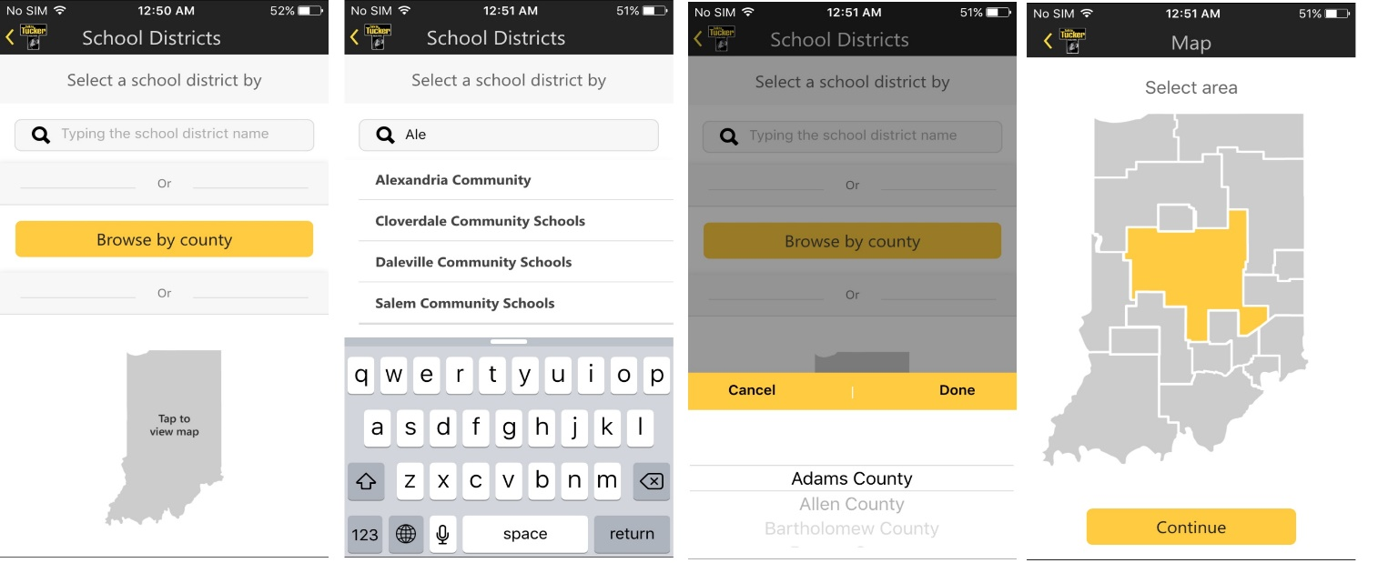

**My Account**

